Calculation Policy
EYFS (Nursery & Reception)
Addition | Subtraction | Multiplication | Division
Children are encouraged to gain a sense of the number system through the use of counting concrete objects. | Children are encouraged to gain a sense of the number system through the use of counting concrete objects. | Children use concrete objects to make and count equal groups of  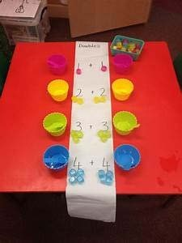  objects.  They will count on in twos using a bead string and number line.  They understand doubling as repeated addition.  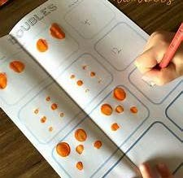  2 + 2 = 4  They use concrete and pictorial representation to record their calculations.  Higher attaining children may be able to represent their  calculations using symbols and numbers within a written calculation. | Children use concrete objects to count and share equally into 2 groups.  6 cakes shared between 2 people each person gets 3 cakes. 6 ÷2 = 3  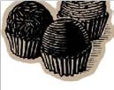  They count a set of objects and halve them by making two equal groups.  They understand sharing and halving as dividing by 2.  They will begin to use objects to make groups of 2 from a given amount.  They use concrete and pictorial representation to record their calculations.
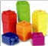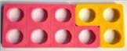
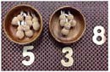  They combine objects in practical ways and count all. | 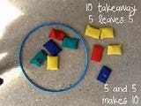  They understand subtraction as counting out.
They understand addition  as counting on and will count on in ones and twos using objects, cubes, bead string and number line.  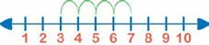 | They begin to count back in ones and twos using objects, cubes, bead string and number line.
They use  concrete and pictorial representation to record their calculations. | 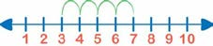
 | They use concrete and pictorial representation to record their calculations.

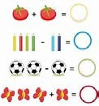  They begin to use + and =  They are encouraged to develop a mental picture of the number system in their heads to use for calculations.  Higher attaining children may be able to represent their calculations using symbols and numbers within a written calculation. | They begin to use - and =  They are encouraged to develop a mental picture of the number system in their heads to use for calculations.  Higher attaining children may be able to represent their calculations using symbols and numbers within a written calculation. |  |   Higher attaining children may be able to represent their calculations using symbols and numbers within a written calculation.

ADDITION - KS1 (Years 1&2)
 | Concrete | Pictorial | Abstract
S  t a g e  1 | 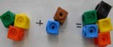  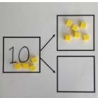  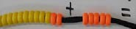  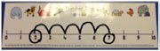  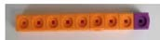  Use part part whole model, cubes and bead strings to add two numbers together as a group or in a bar. | 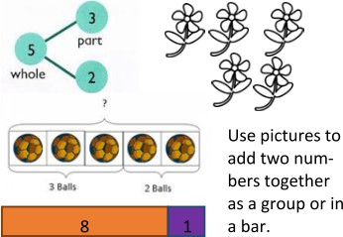  Use jottings to represent numbers. | 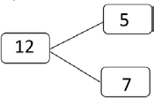  Children will record their calculation using a pictorial method along with a calculation using numbers and symbols.  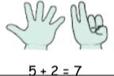  11 + 4 = 15  They may use their fingers to support their mental methods
S  t a g e  2 | Grouping objects to add  Children will use dienes cubes to add larger numbers where regrouping is not required.  They will also use a bead string to add larger numbers by counting in tens and ones | Number line  Start at the larger number on the number line and count on in ones or in one jump to find the answer. Children will show their representations from the concrete method using pictures.  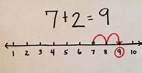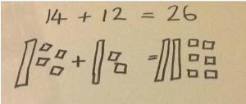 | 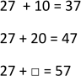  Children will record their calculation using a pictorial method along with a calculation using numbers and symbols.  Children will begin to add multiples of tens.

 | 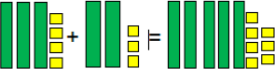 |  | Numbers will get progressively larger throughout the keystage. Children will be able to add tens and ones using an empty number line.
S  t a g e  3 | Partitioning  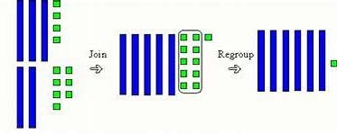  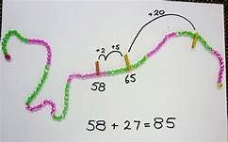  Children will add larger numbers where they will need to join, regroup and count.  Children will also use bead strings to add numbers together using groups of tens and ones to count on. |  | Number line  Use an empty number line to count in tens and then ones.  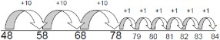  When confident:  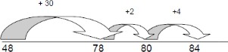 | 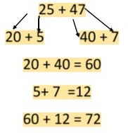  Partitioning  Children will begin to use the partitioning method. Tens and ones will be added to form partial sums and then these partial sums will be added together to find the total.
 |  | Add together the ones first, then add the tens. Use | After physically using the base 10 blocks and place value | 24 + 15 = 39
 |  | the Base 10 blocks first before moving onto place  value counters.  24 + 15 = 44 + 15 =  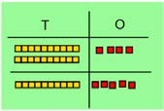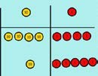 | counters, children can draw the counters to help them to  solve additions.  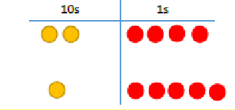 | 24  + 15  39
 |  | Make both numbers on a place value grid | Using place value counters, children can draw the counters | 40 + 9
 |  | 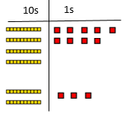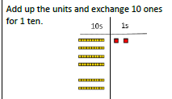 | 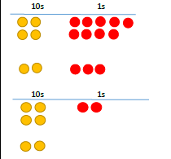  to help them to solve additions. | 20 + 3  60 + 12 = 72
In line with the WR scheme to lead onto column addition with and without regrouping.

Calculation Policy
ADDITION - Lower KS2 (Years 3 & 4)
 | Concrete | Pictorial | Abstract
S  t a g e  1 | Use dienes cubes to consolidate learning from KS1. Ensure children are confident at using these to join, regroup and count. This will support them moving onto the next stage of column addition. | Number line  Consolidate their learning from KS1 by using an empty number line to count larger numbers.  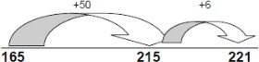 | Partitioning  Children will consolidate using the partitioning method. The layout will begin to form a written method to support further progress onto the column method. Hundreds, Tens and ones will be added to form partial sums and then these partial sums will be added together to find the total.  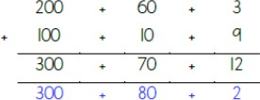
S  t a g e  2 | 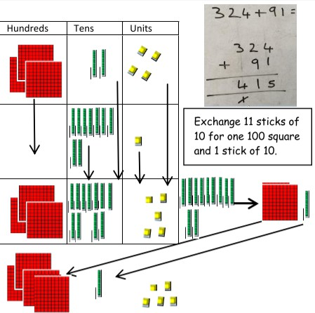  Introduce children to place value counters and dienes cubes. Use the column method layout to support their learning onto the abstract method.  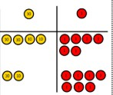 | 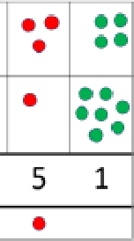  Children can draw a representation of the grid to further support their understanding, carrying the ten underneath the line. | Expanded column method - Formal method  Children to use the Expanded Column Method. Start by partitioning the numbers before the formal column to show the exchange. Once confident, they can move onto the column method in stage 3.  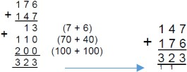

S  t a g e  3 | Children will add larger numbers where they will need to exchange place value counters or dienes cubes.  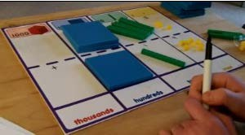 | 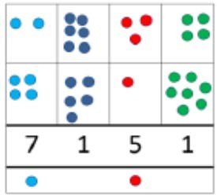  Children can draw a representation of the grid using larger numbers. | Column method - Formal method  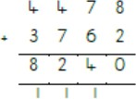  Column Method for addition to be used with more than one exchange.
Calculation Policy
ADDITION - Upper KS2 (Years 5 & 6)
 | Concrete | Pictorial | Abstract
S  t a g e  1 | 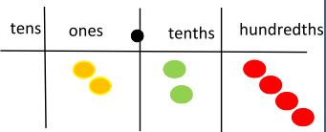  Introduce decimal place value counters and model regrouping for addition. | 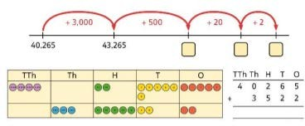  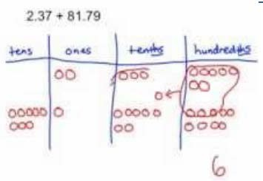  Children will draw their representations showing where they have regrouped. | 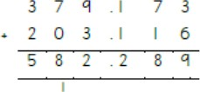  Column method Children will continue to develop their understanding of column method addition. Calculations will become larger  and include decimal places.

S  t a g e  2 | Please note: Concrete apparatus and pictorial representations should still be used to support children who may be struggling with abstract concepts. Concrete apparatus should be readily available for lower achieving children and these with SEND. | 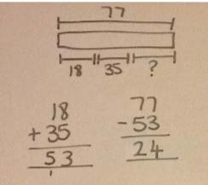  Children will begin to use the bar model when problem solving. Jottings and calculations should be recorded to show their processes. | Column method  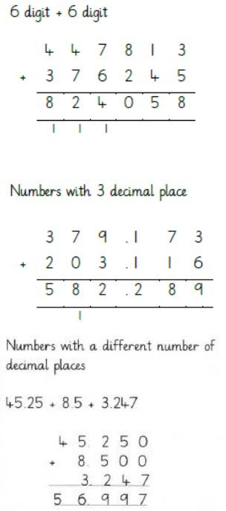  Children to further develop their confidence using the column method. Larger numbers, decimal places and inserting zero for place holders when decimals are different.  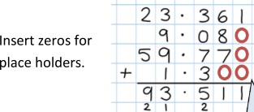
Calculation Policy
SUBTRACTION - KS1 (Years 1&2)
 | Concrete | Pictorial | Abstract
S  t a g e  1 | Taking objects away  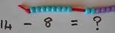  Use part whole model, cubes and bead strings to subtract two numbers together by moving objects away from the group.  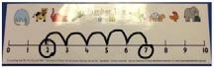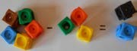 | Use jottings to represent numbers. Children will learn to cross out drawn objects to show what has been taken away.  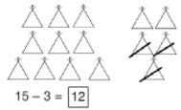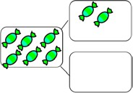 | Children will record their calculation using a pictorial method along with a calculation using numbers and symbols.  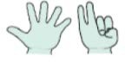  11 - 4 = 7  They may use their fingers to support their mental methods

S  t a g e  2 | 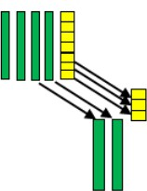  Children will use dienes cubes to subtract larger numbers where exchanging is not required.  Children will lay out the first number using the dienes cubes and then move the second number away to show the subtraction.  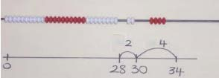  They will also use a bead string to add larger numbers by counting in tens and ones. | 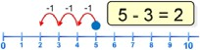  Number line  Children will begin to draw their own number lines. Start at the  larger number on the number line and count back in ones or in one jump to find the answer.  Numbers will get progressively larger throughout the keystage. Children will be able to  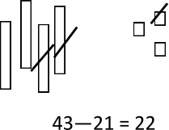  subtract tens and ones using an empty number line.  Children will show their representations from the concrete method using pictures. | Children will record their calculation using a pictorial method along with a calculation using numbers and symbols.  25 - 12 = 13  Children will begin to subtract multiples of tens.  25 - 10  25 - 10 = 15
S  t a g e  3 | 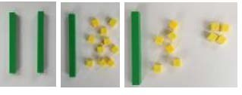  Children will begin to use place value counters and dienes cubes to show how to exchange between units of number. They will be  able to change 1 ten and exchange it for 10 ones. | Empty number line -Use an empty number line to count back in tens and then ones.  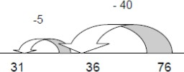  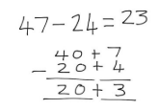  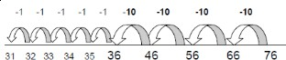  When confident: | Partitioning method  Children will begin to use the partitioning method. Tens and ones will be subtracted to form partial sums and then these partial sums will be added together to find the total.  47 – 23 = 24  47 – 20 = 27  27 – 3 = 24

Calculation Policy
SUBTRACTION - Lower KS2 (Years 3 & 4)
 | Concrete | Pictorial | Abstract
S  t a g e  1 | 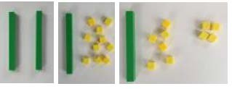  Children consolidate and use place value counters and dienes cubes to show how to exchange between units of number. They will be able to  change 1 ten and exchange it for 10 ones.  They will be able to begin to lay this out like the column method and removing counters or cubes away to represent taking away.  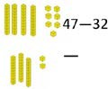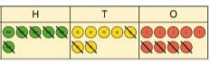 | 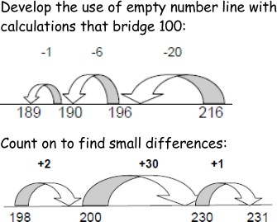  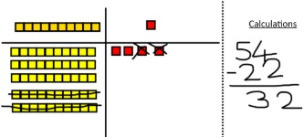  Consolidate their learning from KS1 by using an empty number line to calculate larger numbers.  Children will also be able to draw representations of dienes cubes and place value counters by crossing out the  number being taken away. | 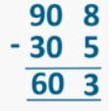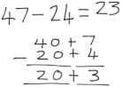  Children to further secure their knowledge using the partitioning method but will start to lay their work out using the column method approach. Tens and ones will be subtracted to form partial sums and then these partial sums will be added together to find the total.
S  t a g e  2 | 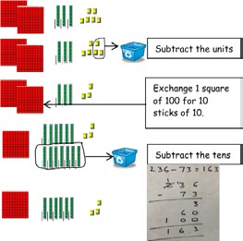  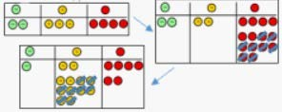  Children begin to set out HTU - HTU using dienes cubes and place value counters (that cross the tens boundary) in columns and record as column subtraction with decomposition. Teach children how to exchange units of numbers. | 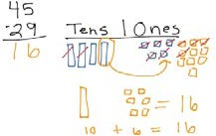  Children may draw dienes cubes or place value counters and cross off showing their understanding of taking away. They will need to represent any exchanging that takes place.  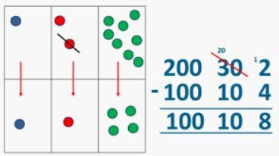 | Partitioning method - with exchanging  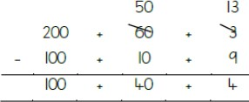  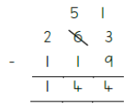  Children will use the partitioning method to show exchanging.  Once confident, children can start to use the column method.
S  t a g e | 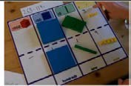  Children continue to develop their confidence in using dienes cubes and place value counters to show decomposition using the column method. | Children draw representations from concrete activities | Column Method  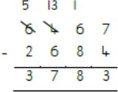  Children continue to use column method to subtract larger numbers.

3 |  | 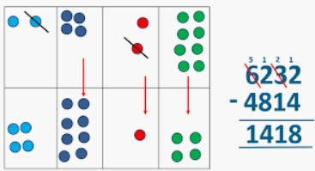  using dienes cubes and place value counters.
Calculation Policy
SUBTRACTION - Upper KS2 (Years 5 & 6)
 | Concrete | Pictorial | Abstract
S  t a g e  1 | Please note: Concrete apparatus and pictorial representations should still be used to support children who may be struggling with abstract concepts. Concrete apparatus should be readily available for lower achieving children and these with SEND. | 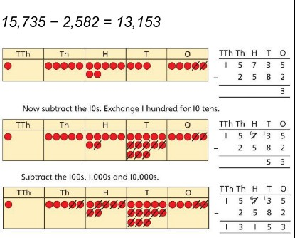  Children can draw using place value counters showing how exchanging takes place between the units of numbers.  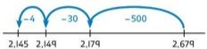  Children also show subtraction on an empty number line using larger numbers. | 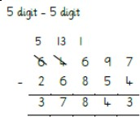  Column Method Children will continue to develop their understanding of column method subtraction.  Calculations will become larger.
S  t a g e  2 | Introduce decimal place value counters and model | Children will draw their representations showing where they have exchanged.  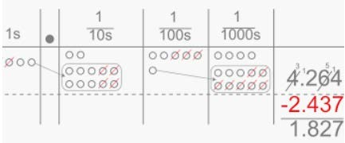 | Children will continue to develop their understanding of column method subtraction. Calculations will become larger, include decimal places and require 0 to be added as

 | 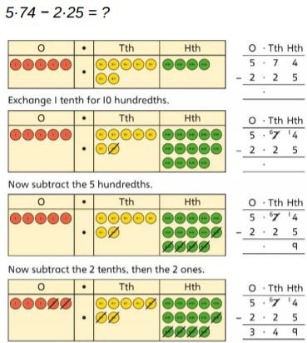  exchange for subtracting between units of numbers. |  | 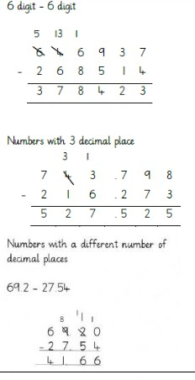  a placeholder with more than one exchange.

Calculation Policy
MULTIPLICATION - KS1 (Years 1&2)
 | Concrete | Pictorial | Abstract
S  t a g e  1 | 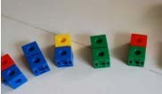  Repeated addition - Groups of multiple objects  Children will count groups of the same number of objects and add them together. The children learn about grouping  in practical contexts and through pictorial representations. | 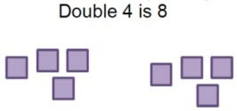  Children draw representations to show counting in multiples and groups.    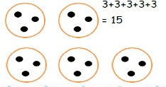 | Children show multiplication as repeated addition. Children may provide pictorial representations to support.  3 x 9  3 + 3 + 3 = 9
S  t a g e  2 | Arrays  Children will be able to represent a multiplication calculation using an array  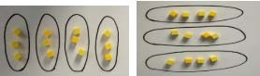  and write the multiplication symbol within a number sentence. Children will  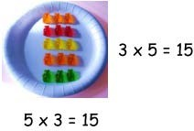  also understand that multiplication can be carried out in any order (commutative).  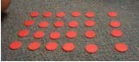 | 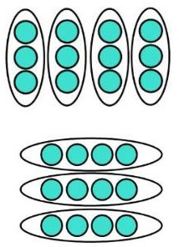  Children draw representations to show arrays. | Children use arrays to show how to solve multiplication calculations. Children are able to show that multiplication can be done in any order  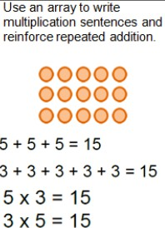  (commutative).  3 x 5 = 15  5 x 3 = 15  Introduce x sign and record as number sentence  7 x 10 = 70  4 x 5 = 20
S  t a g e  3 | Number line  Children will understand the operation of multiplication as repeated addition on a blank number line and will use practical resources to support this. Count the groups as children are skip counting, children may use their fingers as they are skip counting. | 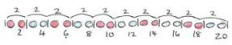  Children will be able to use an empty number line to show multiplication as repeated addition. The use of beadsting concrete resources may be used to support conceptual understanding.  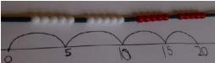 | Children show multiplication as repeated addition.  5 + 5 + 5 = 15  Introduce x sign and record as number sentence  7 x 10 = 70

 | 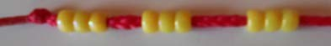  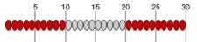 | 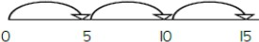 | 4 x 5 = 20
Calculation Policy
MULTIPLICATION - Lower KS2 (Years 3 & 4)
 | Concrete | Pictorial | Abstract
S  t a g e  1 | Partitioning  Children will learn to multiply ones and tens separately before recombing the numbers back together. They can use Dienes cube of place value counters to achieve this.  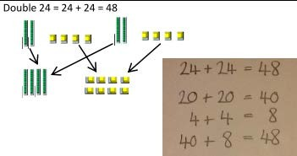 | Children can draw representations of the partitioning process to support their conceptual understanding.  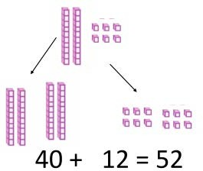 | Partition a number and then multiply each part before recombining it back together.  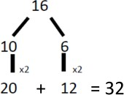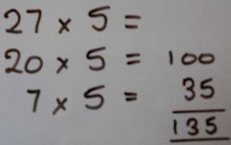
S  t a g e  2 | 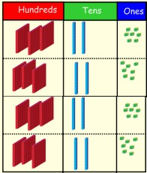  Grid Method  Show the links with arrays to first introduce the grid method.  Move onto Dienes cubes to move towards a more compact method.  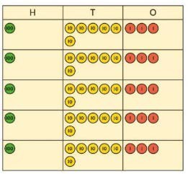  Move on to place value counters to show how we are finding groups of a number. We are multiplying by 5 so we need 5 rows of that number. | Pictorial representations can be made using their concrete manipulatives as  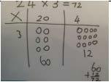  visuals. They can draw the counters using colours to show different amounts or just use the circles in the different columns to show their thinking as shown.  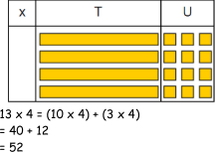 | 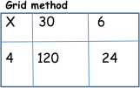  Children should be able to draw the grid method for each multiplication. The grid method will be used to show how this relates to a formal written method.  Grid method may then  lead to the expanded method.  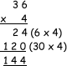

S  t a g e  3 | Concrete materials may be needed to support children’s |  | Use place value equipment to compare methods.  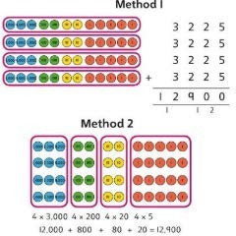 | The grid method may be used to show how this relates to a
S  t a g e  3 | conceptual understanding. Dienes cubes and place value |  |  | formal written method.
S  t a g e  3 | counters will |  |  | Grid method will lead onto expanded method and then onto
S  t a g e  3 | 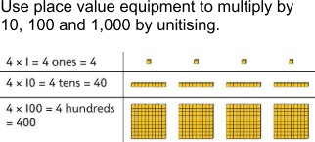  support. |  |  | the compact short multiplication.
S  t a g e  3 | 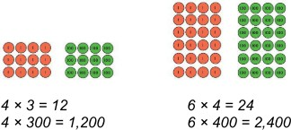  When multiplying by 10,100,1000 initial concrete resources will be used to support understanding. |  |  | 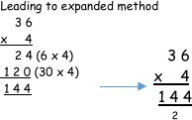  Use known facts and unitising to multiply. 5 × 4 = 20  5 × 40 = 200
S  t a g e  3 |  |  |  | 5 × 400 = 2,000
S  t a g e  3 |  |  |  | 5 × 4,000 − 20,000
S  t a g e  3 |  |  |  | 5,000 × 4 = 20,000
In line with the WR scheme to lead onto the expanded method from the grid method. |  | 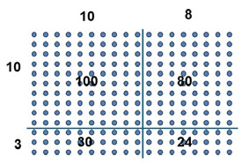  Show the link with arrays to first introduce the expanded method. | 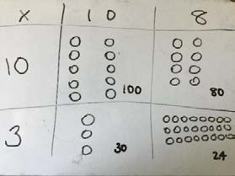 | 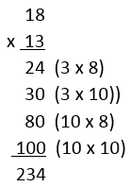  Start with long multiplication, reminding the children about lining up their numbers clearly in columns.

Calculation Policy
MULTIPLICATION - Upper KS2 (Years 5 & 6)
 | Concrete | Pictorial | Abstract
S  t a g e  1 | 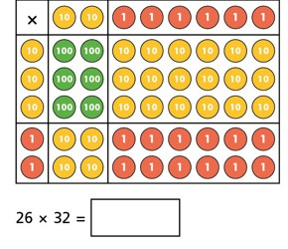  The area model reinforces their knowledge of the grid method  . | 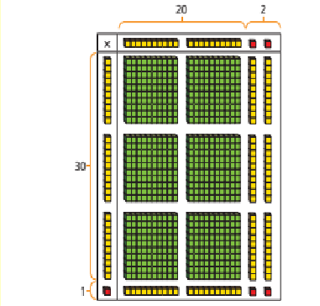 | 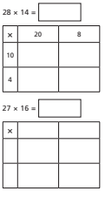  Children use this model to be able to multiply two digit by two digit numbers.
S  t a g e  2 | 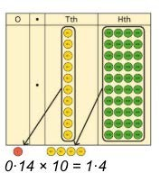  When multiplying decimals by 10,100,1000 initial concrete resources will be used to support understanding to show how exchanging can take place. | This pictorial grid method will support children’s understanding of multiplying by 10, 100, 1000.  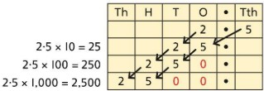 | Long multiplication  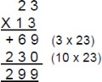  Children may wish to use 2 separate calculations to support their understanding. Reinforce language of place value when multiplying by multiples of 10. Extend to 3 or 4-digit numbers multiplied by a 2-digit number.
S  t a g e  3 | Please note: Concrete apparatus and pictorial representations should still be used to support children who may be struggling with abstract concepts. Concrete apparatus should be readily available for lower achieving children and these with SEND. | Please note: Concrete apparatus and pictorial representations should still be used to support children who may be struggling with abstract concepts. Concrete apparatus should be readily available for lower achieving children and these with SEND. | Use column multiplication, ensuring understanding of place value at each stage.  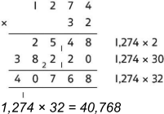

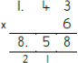
Calculation Policy
DIVISION - KS1 (Years 1&2)
 | Concrete | Pictorial | Abstract
S  t a g e  1 | 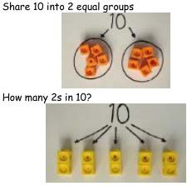  Sharing and Grouping Divide quantities into equal groups. Use cubes, counters, objects or place value counters to aid understanding. | Use pictures to share objects. Use circles rather than dots to aid counting.  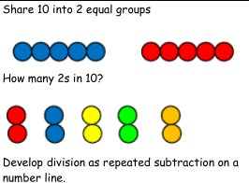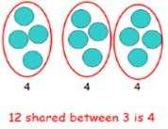 | Children will be able to represent a division calculation using a pictorial method and write the division within a number sentence.  10 ÷ 2 = 5  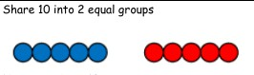
S  t a g e  2 | Arrays  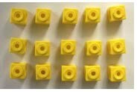  Link division to multiplication by creating an array and thinking about the number sentences that can be created.  Eg:  15 ÷ 3 = 5 5 x 3 = 15  15 ÷ 5 = 3 3 x 5 = 15 | Draw arrays to show how pictures are divided.  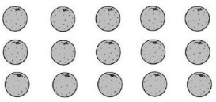 | 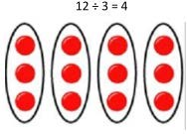  Children will be able to represent a division calculation using an array and write the division within a number sentence
S | Repeated addition and subtraction | Children will understand the operation of division as | Children will be able to represent a division calculation

t a g e  3 | Children will understand the operation and repeated addition or subtraction using bead strings and number lines. This  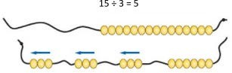  will support the pictorial element. | 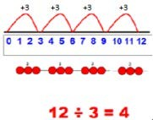  grouping using repeated addition or subtraction on a prepared number line. | using a numberline and write the division within a number sentence.

Calculation Policy
DIVISION - Lower KS2 (Years 3 & 4)
 | Concrete | Pictorial | Abstract
S  t a g e  1 | Division with no remainders through sharing. Use concrete materials to share into groups.  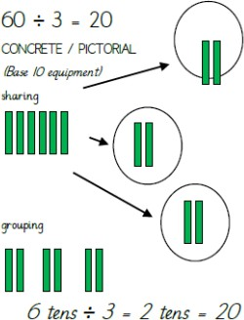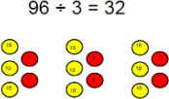 | Consolidate learning from KS1 using diagrams of sharing and repeated subtraction and addition on a number line to make jumps  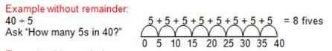  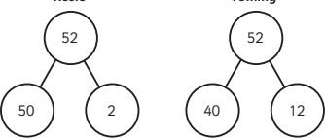  Concrete methods could be represented pictorially within books to show understanding. | How many groups of 6 in 24?  24 ÷ 6 = 4  Abstract methods may be supported with pictorial methods within the children’s books.

S  t a g e  2 | 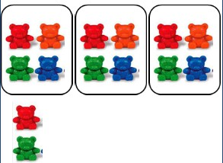  Division with remainder through sharing  14 ÷ 3 =  Divide objects between groups and see how much is left over.  Division no remainders - introduction to bus stop method  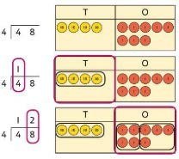  Use place value equipment on a place value grid alongside short division.  The model uses grouping. | Students can continue to use drawn diagrams with circles to help them divide numbers into equal groups.  Remainders will be seen by not fitting into a whole group.  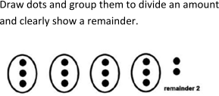  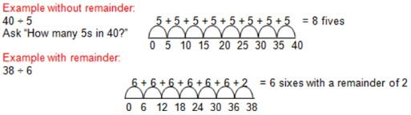 | Children will begin to move onto division with remainders. A number sentence will support any abstract written calculation by using pictorial method to support.  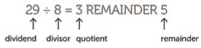  Short division  Children will begin to use the formal written method of division without remainders. This will only come after a clear concept is understood using manipulatives.  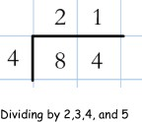
S  t a g e  3 | 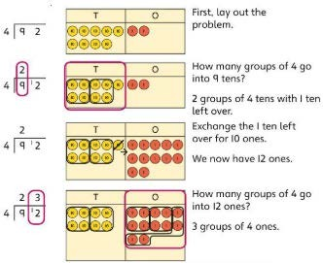    Division with remainders | 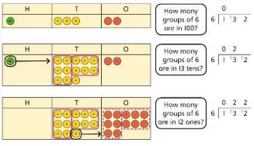    Pictorial representations can be used to support any concrete manipulatives.  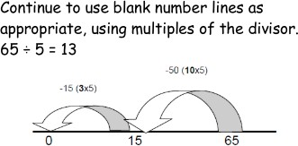 | 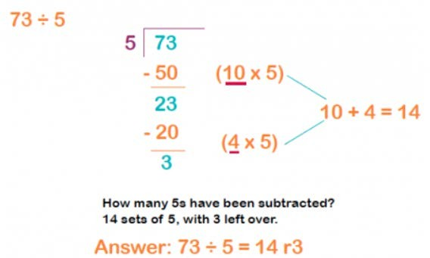  Reinforcing the part/whole model to support division of larger numbers

Calculation Policy
DIVISION - Upper KS2 (Years 5 & 6)
 | Concrete | Pictorial | Abstract
S  t a g e  1 | Dividing whole numbers by 10, 100 and 1,000  Use place value equipment to support unitising for division.  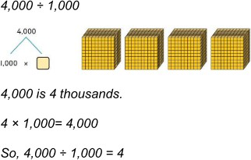  Concrete and pictorial representations may still be required to support the formal method of division (Bus Stop) - Go back to LKS2 to consolidate learning. | Understand how and why the digits change on a place value grid when dividing by 10, 100 or 1,000.  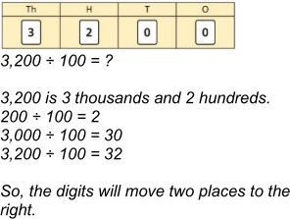 | Chunking  Chunking is repeated subtraction of the divisor and multiples of the divisor.  Bus Stop Method for division  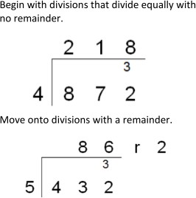

S  t a g e  2 | Dividing decimals by 10, 100 and 1,000  Use place value counters to represent dividing by 10, 100, 1000. Represent division using exchange on a place value grid.  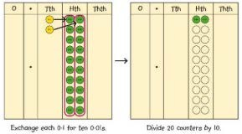  0·2 is 2 tenths.  2 tenths is equivalent to 20 hundredths. 20 hundredths divided by 10 is 2 hundredths. | Represent division to show the relationship with multiplication. Understand the effect of dividing by 10, 100 and 1,000 on the digits on a place value grid.  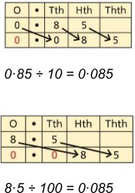 | Finally move into decimal places to divide the  total accurately using a formal method for division (Bus stop)  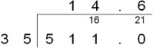
S  t a g e  3 | Long Division - Abstract Method  Calculations will start with tens and ones and move onto more advanced division calculations.  

