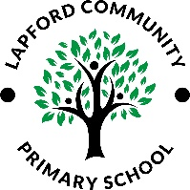
Lapford Community Primary School
Music Knowledge and Skills Progression – Set out by Charanga Music

ELG: Being Imaginative and Expressive
Sing a range of well-known nursery rhymes and songs; Perform songs, rhymes, poems and stories with others, and – when appropriate – try to move in time with music.
National Curriculum
Key stage 1 Pupils should be taught to:  - use their voices expressively and creatively by singing songs and speaking chants and rhymes  - play tuned and untuned instruments musically  - listen with concentration and understanding to a range of high-quality live and recorded music  - experiment with, create, select and combine sounds using the inter-related dimensions of music. | Key stage 2 Pupils should be taught to:  - sing and play musically with increasing confidence and control.  - develop an understanding of musical composition, organising and manipulating ideas within musical structures and reproducing sounds from aural memory.  - play and perform in solo and ensemble contexts, using their voices and playing musical instruments with increasing accuracy, fluency, control and expression  - improvise and compose music for a range of purposes using the inter-related dimensions of music  - listen with attention to detail and recall sounds with increasing aural memory  - use and understand staff and other musical notations  - appreciate and understand a wide range of high-quality live and recorded music drawn from different traditions and from great composers and musicians  - develop an understanding of the history of music



