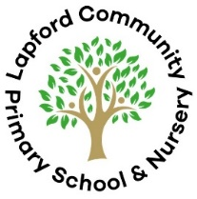  Herons Class  Autumn 1 2025 | Area of learning: History  Big Question: What was important to Ancient Egyptians?  Memorable Moment: Time Odyssey - augmented reality technology visit to RAMM
 | Herons will be travelling back in time to explore the core aspects of ancient Egyptian civilisation. We will learn about the significance of religion, the River Nile, the afterlife, and the development of hieroglyphic writing. Herons will find out about key beliefs such as the worship of numerous gods, the process of mummification, and the importance of the soul’s journey after death. Herons will develop an awareness of how historians learn about the past using mummies, the Book of the Dead and pyramids. They will learn how the ancient Egyptians explained the existence of the world using their creation story.

English
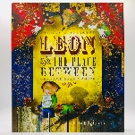
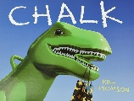
Y3 and 4 Texts:
Years 3 and 4 will be creating their own stories about a drawing or model which comes to life as we explore ‘Chalk’ by Bill Thomson and magic and mysterious portals in ‘Leon and the Place Between!’
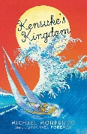
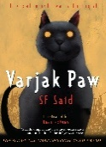
Y5 and 6 Texts:
Years 5 and 6 will be delving deep into the excellent ‘Kensuke’s Kingdom’ by Michael Morpurgo and ‘Varjak Paw’ by SF Said to create our own chapters in the style of these authors.
 | Science |  | Art/Design Technology
 | Y3/4 – States of matter and changing states  Years 3 and 4 will be exploring how matter changes from one state to another through practical experiments including solids, liquids and gases, the water cycle and melting.  Y5/6 – Properties, changes and separating materials  Years 5 and 6 will be investigating the suitability of materials in terms of thermal and electrical conductivity, how materials are altered both reversibly and irreversibly and solubility through a variety of hands-on experiments. |  | Ancient Egyptian scrolls  To coincide with our History topic on Ancient Egypt, Herons will be researching various techniques from this time period before creating their own scrolls and crafts!
Maths | RE | Computing | Music
Each year group will receive differentiated lessons/learning while studying the main key areas below:  Place Value – Recapping on prior knowledge of number systems and how we read, compare and understand numbers of differing size.  Addition and Subtraction – We will be building on our skills of column method, inverse operations and estimation to solve problems and reason logically.  Times and Divide – Herons class will be using their knowledge of times table facts to further improve their abilities to solve problems, reason and unpick their understanding of multiplication and division. | What is the Trinity and why is it important for Christians?  Across this unit, Herons will be researching the importance of the Trinity for Christians before comparing Christian belief to their own ideas and understandings of the world. | Coding 3.1 – Herons will be creating their own working codes and flowcharts to produce an animated scene.  Coding 5.1 – Building upon prior knowledge, Herons will be creating their own strings or lines of code to generate their own silly sentences. | Compose using Your Imagination  Use your imagination when creating your compositions in this unit. What do you see when you close your eyes? Can you write a melody or find sounds that represent the story you want to tell?
 | PE | French | PSHE
 | Swimming  Strategy and Tactics | L’ancienne histoire de la Grande Bretagne (Ancient Britain)  Herons will be working on how to apply their conversational skills in French to the topic of Ancient Britain. | Keeping and Staying Safe  In this unit children will consider how to stay safe in a range of situations including cycle and water safety.

