  Kingfishers Class:  Year 1 and 2  Autumn 1 2025 |  | Area of learning: History  Big Question: Who do we remember and why?  Memorable Moment:
War and Remembrance
Children learn about the First World War and Remembrance Day. They find out about Walter Tull, a significant individual in British history who was the first black British Army officer. They deepen their historical awareness and understanding by studying photographic primary sources. They find out why and how Remembrance Day is marked, the experiences of soldiers in the trenches, the animals who helped them and the importance of women's roles on the Home Front.

English
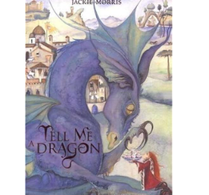
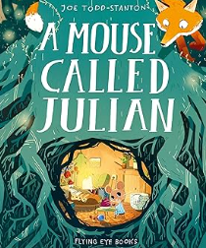
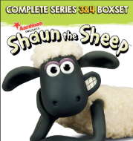

Shaun the Sheep The Complete First Series by Aardman
A Mouse Called Julian by Joe Todd-Stanton
Tell Me A Dragon by Jackie Morris

 |  | Phonics |  |  | Science
 |  | Year 1 Level 5 sounds and Tricky Words | ‘ay, ‘oy’, ‘ie’, ‘ea’, ‘a-e’, ‘i-e’  could, should, would, want, Mr, Mrs, love, your, people, looked |  | Naming and grouping animals  Children will explore the world of animals by learning how to name, describe, and group them based on their features. They will discover that animals can be sorted in different ways. They will learn to spot the differences between these groups and understand that animals have features that help them survive in their environments.
 |  | Year 2 Level 6 sounds and Tricky Words | ‘igh’, ‘dge’, ‘ge’, ‘gn’, ‘kn’, ‘wr’  door, floor, bought, favourite, autumn, gone, know, colour, other, does
 |  | Year 2 Grammar Focus | Focus on capital letters, full stops and finger spaces. Recap of capital letters and full stops, common nouns, plural nouns, subordinating conjunctions
Maths |  | RE |  | Computing | PSHE
Place Value within 20  Count objects within 10  Represent numbers to 10  Count on and back within 20  Understand 10  Understand 11-15  Understand 16-20  1 more  1 less  Number lines  Estimate number lines  Less than, greater than, equal to  Compare numbers  Order numbers | Addition and subtraction within 20  Parts and wholes  Systematic number bonds within 10  Number bonds to 10  Number bonds to 20  Addition – add together  Addition – add more  Doubles  Near doubles  Add three 1-digits  Find a part  Fact families  Take away  Find the difference  Missing number problems | Who do Christians say made the world? |  | Technology Outside school 1.9  Effective searching 2.5 | Keeping/Staying Safe  Baseline  Road Safety  Tying Shoelaces
 |  | PE |  | Music | Art/ Design Technology
 |  | Balance and Shape Y1  Ball Skills: Hands Y2 |  | Charanga: Learning to listen  In this unit the children will be listening, singing, playing composing and improvising with a range of music from pop to 21st century orchestral. Children will focus on finding and feeling a beat or pulse before moving on to listen for other musical elements including rhythm and pitch. | Colour Splash  (Painting and Mixed Media)

