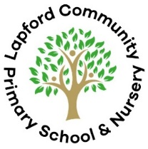  Robins Class: EYFS  Autumn 1 2025  People Who Help Us |  | Big Question: How Do People in the Community Help Us?  Memorable Moment: Scribbleton / Dress-up Day  Celebration Task: Diwali Celebration
 |  | Phonics |  | Understanding the world
 |  | Nursery  Level 1:  Environmental sounds, instrumental sounds, body percussion, rhythm and rhyme, alliteration, voice sounds, oral blending and segmenting. |  | - My Community  - Jobs – How do people help us?  - Past and present  - Using our senses  - Autumn  - Using technological toys

English
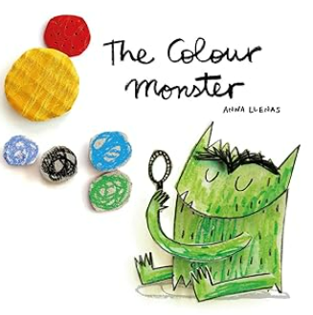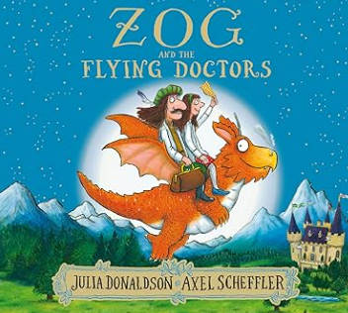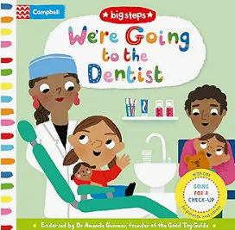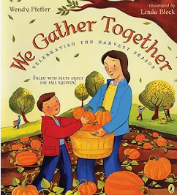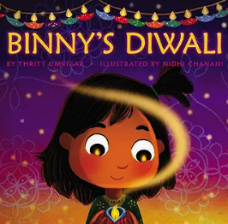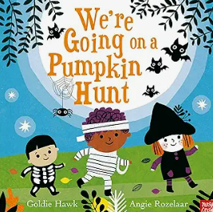
Reception
Level 2 sounds:
s a t p i n m d g o c k ck e u r h b f l ff ll ss ‘s’ saying /z/
Tricky words:
To, the, no, go, I

Handwriting:
Letter and number formation, strengthening hand and finger muscles and drawing different lines
 |  |  |  | Expressive Arts and Design
- Colour mixing
- Autumn Collage
- Clay sculpting (Diwali Lights)
- Rangoli
- Pumpkin printing
- Roleplay: School, Drs/Dentist, Charities
Maths |  | Music | Physical Development |  | PSED
Reception:  Match, Sort and Compare  Match Pictures and Objects  Identify a Set  Sort Objects to a Type  Explore Sorting Techniques  Create Sorting Rules  Compare Amounts  Talk About Measure & Patterns  Compare Size, Mass and Capacity  Explore and Create Simple Patterns  Copy and Continue Simple Patterns | It’s Me, 1, 2, 3  Find 1, 2, 3  Subitise 1, 2, 3  Represent 1, 2, 3  1 More  1 Less  Composition of 1, 2, 3  Nursery:  More Than, Fewer Than, Same  Explore and Build with Shapes and Objects  Explore Repeats | Charanga: Me!  Nursery Rhymes  Pat-a-cake  Here We Go Round the Mulberry Bush  If You’re Happy and You Know It  Miss Polly Had a Dolly  This is the Way  Oats and Beans and Barley Grow  Twinkle, Twinkle Little Star  1 Little, 2 Little, 3 Little Pumpkins | PE with Mrs Perry:  ‘Me and PE’  Team Building  Turn Taking  Safe Movement  In the Classroom:  Squiggle whilst you wiggle  Fine-Motor Carousel  Mark-Making Directed Activities  Dough Disco! |  | Hygiene Routines in School  Emotions – Settling in and Making Friends  Toothbrushing  My Community
 |  |  |  |  | RE
 |  |  |  |  | Why is the word God so important to Christians?

