Dishes and their allergen content – Autumn Menu Week 1 Primary Schools (2026)

Dishes | 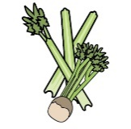 | 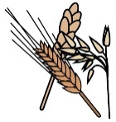 | 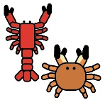 |  | 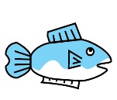 | 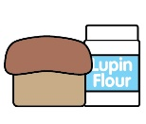 |  |  | 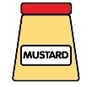 | 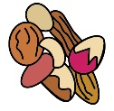 | 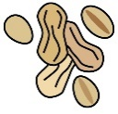 | 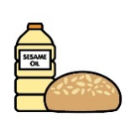 |  | 
 | Celery | Cereals containing gluten* | Crustaceans | Eggs | Fish | Lupin | Milk | Mollusc | Mustard | Nuts† | Peanuts | Sesame seeds | Soya | Sulphur Dioxide
Bolognese, Focaccia and veg |  | ✓ |  |  |  |  |  |  |  |  |  |  | ? | ✓
Veg Bolognese, Focaccia and veg |  | ✓ |  |  |  |  |  |  |  |  |  |  | ✓ | ✓
Pork Sausage, mash, gravy |  |  |  |  |  |  |  |  |  |  |  |  |  | ✓
Veg Sausage, mash, gravy |  | ✓ |  |  |  |  |  |  |  |  |  |  |  | ✓
Roast Chicken |  |  |  |  |  |  |  |  |  |  |  |  |  | ✓
Cheese & Leek Pie |  |  |  |  |  |  | ✓ |  |  |  |  |  |  | ✓
Fish cakes, wedges and salad |  | ✓ |  |  | ✓ |  | ✓ |  | ✓
Veg curry Rice & Salad
Chicken chunks chips & Peas |  | ✓
Veg nugget chips & peas |  | ✓
Dishes
 | Celery | Cereals containing gluten* | Crustaceans | Eggs | Fish | Lupin | Milk | Mollusc | Mustard | Nuts† | Peanuts | Sesame seeds | Soya | Sulphur Dioxide
Custard Cookie |  | ✓ |  | ? |  |  |  |  |  |  |  |  | ?
Chocolate Cake |  | ✓ |  | ✓ |  |  |  |  |  |  |  |  | ?
Strawberry Mousse |  |  |  |  |  |  | ✓
Apple Toffee cake |  | ✓ |  | ✓ |  |  |  |  |  |  |  |  | ?
Flapjack |  | ✓
Cheese Jacket Potato |  |  |  |  |  |  | ✓
Tuna Mayo Jacket Potato |  |  |  | ✓ | ✓ |  |  |  | ?
Bean Jacket Potato
Ham s/wich |  | ✓ |  |  |  |  |  |  |  |  |  |  | ✓
Cheese s/wich |  | ✓ |  |  |  |  | ✓ |  |  |  |  |  | ✓
Tuna mayo s/wich |  | ✓ |  | ✓ | ✓ |  |  |  | ? |  |  |  | ✓

