Dishes and their allergen content – Autumn Menu 2026, Week 2 - Primary
Dishes | 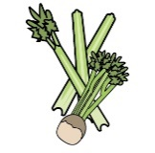 | 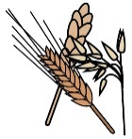 | 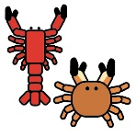 |  | 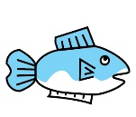 | 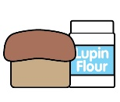 |  |  | 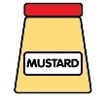 | 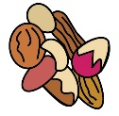 | 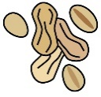 | 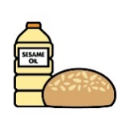 |  | 
 | Celery | Cereals containing gluten* | Crustaceans | Eggs | Fish | Lupin | Milk | Mollusc | Mustard | Nuts† | Peanuts | Sesame seeds | Soya | Sulphur Dioxide
Chilli Con carne |  |  |  |  |  |  |  |  |  |  |  |  |  | ✓
Veg Chilli |  |  |  |  |  |  |  |  |  |  |  |  |  | ✓
Chicken Flatbread |  | ✓ |  | ✓ |  |  | ✓ |  | ?
Veg Flatbread |  | ✓ |  | ✓ |  |  | ✓ |  | ?
Roast Gammon |  |  |  |  |  |  |  |  |  |  |  |  |  | ✓
Veg Yorkshire pudding |  | ✓ |  | ✓ |  |  | ✓ |  |  |  |  |  |  | ✓
Katsu Chicken
Quorn Katsu |  | ✓ |  | ✓ |  |  |  |  |  |  |  |  | ?
Fish Fingers, Chips, Peas |  |  |  |  | ✓
Pinwheel |  | ✓ |  |  |  |  | ✓ |  |  |  |  |  |  | ✓
Dishes
 | Celery | Cereals containing gluten* | Crustaceans | Eggs | Fish | Lupin | Milk | Mollusc | Mustard | Nuts† | Peanuts | Sesame seeds | Soya | Sulphur Dioxide
Banana Marble Cake |  | ✓ |  | ✓ |  |  |  |  |  |  |  |  | ?
Shortbread Biscuit |  | ✓ |  |  |  |  |  |  |  |  |  |  | ?
Summer Fruit Strudel & custard |  | ✓ |  |  |  | ? | ✓ |  | ? |  |  |  | ?
Choc Brownie |  | ✓ |  | ✓ |  |  |  |  |  |  |  |  | ?
Rasp muffin |  | ✓ |  | ✓ |  |  |  |  |  |  |  |  | ?
Cheese Jacket Potato |  |  |  |  |  |  | ✓
Tuna Mayo Jacket Pot |  |  |  | ✓ | ✓ |  |  |  | ?
Bean Jacket Potato
Ham s/wich |  | ✓ |  |  |  |  |  |  |  |  |  |  | ✓
Cheese s/wich |  | ✓ |  |  |  |  | ✓ |  |  |  |  |  | ✓
Tuna mayo s/wich |  | ✓ |  | ✓ | ✓ |  |  |  | ? |  |  |  | ✓

