Dishes and their allergen content – Autumn Menu Week 3 Primary Schools (2026)

Dishes | 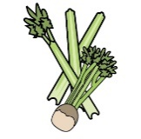 | 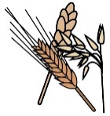 | 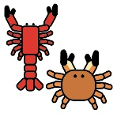 |  |  | 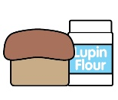 |  |  | 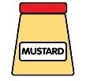 | 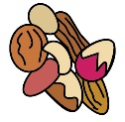 |  | 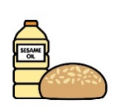 |  | 
 | Celery | Cereals containing gluten* | Crustaceans | Eggs | Fish | Lupin | Milk | Mollusc | Mustard | Nuts† | Peanuts | Sesame seeds | Soya | Sulphur Dioxide
Southern Fried Chicken | ✓ | ✓ |  | ✓ |  |  | ✓ |  | ✓
Veg Burger |  | ✓ |  |  |  |  |  |  |  |  |  | ?
Sausage Plait |  | ✓ |  |  |  | ? |  |  | ? |  |  |  | ? | ✓
Quorn hotdog |  | ✓ |  |  |  |  |  |  |  |  |  |  | ? | ✓
Roast Pork |  |  |  |  |  |  |  |  |  |  |  |  |  | ✓
Beet & Lentil Wellington |  | ✓ |  |  |  |  |  |  |  |  |  |  |  | ✓
Beef Lasagne, Focc |  | ✓ |  |  |  |  | ✓ |  | ✓ |  |  |  | ? | ✓
GF Lasagne |  |  |  |  |  |  | ✓ |  | ✓ |  |  |  |  | ✓
Veg Lasagne |  | ✓ |  |  |  |  | ✓ |  | ✓ |  |  |  | ? | ✓
Ham Pizza |  | ✓ |  | ✓ |  |  | ✓ |  | ? |  |  |  | ? | ✓
GF Ham Pizza |  |  |  | ✓ |  |  |  |  | ? |  |  |  |  | ✓
Marg Pizza |  | ✓ |  | ✓ |  |  | ✓ |  | ? |  |  |  | ? | ✓
Dishes
 | Celery | Cereals containing gluten* | Crustaceans | Eggs | Fish | Lupin | Milk | Mollusc | Mustard | Nuts† | Peanuts | Sesame seeds | Soya | Sulphur Dioxide
Orange Cookie |  | ✓ |  |  |  |  |  |  |  |  |  |  | ?
Strawberry jelly & fruit
Choc Mousse |  |  |  |  |  |  | ✓
Blueberry Flapjack |  | ✓
Fresh Fruit Platter
Cheese Jacket Potato |  |  |  |  |  |  | ✓
Tuna Mayo Jacket Potato |  |  |  | ✓ | ✓ |  |  |  | ?
Bean Jacket Potato
Ham s/wich |  | ✓ |  |  |  |  |  |  |  |  |  |  | ✓
Cheese s/wich |  | ✓ |  |  |  |  | ✓ |  |  |  |  |  | ✓
Tuna mayo s/wich |  | ✓ |  | ✓ | ✓ |  |  |  | ? |  |  |  | ✓

